Versi Template Guide

What is Versi?
The Versi template is an HTML design template whose goal is to increase the productivity of developers when building or rapid prototyping applications. Because designing and wiring up a user interface is one of the most time consuming parts of the development cycle, Versi includes pre-wired XQuery example pages, UI modules, and widgets that can be customized to suit your application.

Versi also includes a host of features to begin wiring up AJAX applications without the tedious setup process.

Features include:
- Modular design
- Sciptaculous Javascript framework
- Global Javascript library
- Design widgets
- Prewired XQuery pages with supporting modules

Building Applications with Versi

The Least You Need to Know
After you have added Versi to your project, you can start building pages by doing the following:

- Create a new page by copying one of the example pages.
- Add your params to the page by using lib-uitools(in the “lib” directory of Subversion) or some custom code.
- Build your display components in modules/display.xqy.
- Add your components to the page, and pass the page params to them.

Column Layouts
Versi was prebuilt with single-, two- and three-column layouts. Each of these three columns can be used for different purposes:

- Primary: The main content column.
- Sidebar: A global sidebar intended for subnavigation and global elements. By default placed on the left-side of the page.
- Secondary: Sidebar intended for content-related items such as related links and navigation. By default placed on the right-side of the page.

CSS and JavaScript
If you would like to update the CSS styles or add your own JavaScript functions to the page, there are already files wired up for you: appspecific.css and appspecific.js. Simply add your new code to these files and all pages will receive the changes. An example appspecific.css is provided in the root code directory.

Additionally, each page also provides the option of adding new <link> and <script> elements to an individual page using the page:build-page-info() function.

There are three core stylesheets:
- template.css: Global styles. Please do not modify.
- basicui.css: Global styles for prebuilt UI components (see below for examples).
- appspecific.css: Put your style overrides and custom styles here!

There are two core JavaScript files:
- ui.js: Global javascript for the template. Please contribute good functions back to the project!!!
- appspecific.js: Put your custom javascript here!

Template Architecture
The core template is constructed using a number of primary design sections that are defined in the global stylesheet:

- Utility: Global links (uses ul.flatlinks)
- Header: Main Logo, Quicksearch, and Tabs
- Subheader: Content to be displayed below the tabs, such as sub-navigation or page-specific information.
- Content: Where columns or content are placed.
- Footer: For copyright, footer links, et al.

All global UI components are then placed into one of these sections and defined in the Basic UI stylesheet.

Quirks & Gotchas
- Versi must be installed into the root directory of the web site. This will hopefully change in future releases, but is necessary for now due to a caching bug/lacking feature with Mark Logic.
- You must have xmlns=”http://www.w3.org/1999/xhtml” on your HTML tag. THE LAYOUT WILL NOT BEHAVE PROPERLY IF THIS IS NOT PRESENT.

Resources
For more images and icons, we recommend famfamfam’s “silk” icon set available:
http://www.famfamfam.com/lab/icons/silk/

Versi Widget Reference

Quicksearch Panel
Element to use: <div class=”quicksearch”>
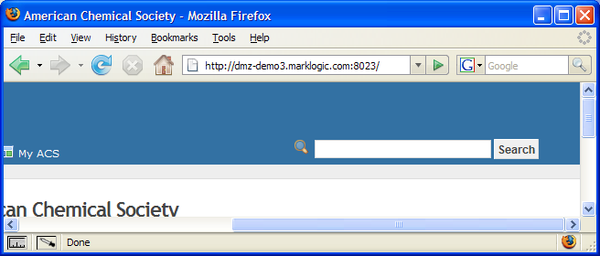

Stack Menu
Element to use: <ul class=”stackMenu”>
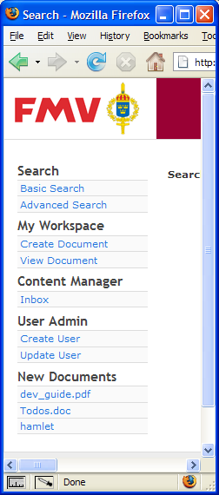

Block Menu
Element to use: <ul class=”blockMenu”>
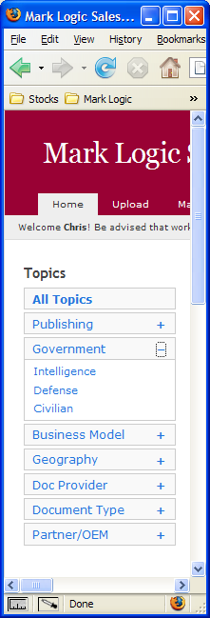

Form Styles
Element to use: <form class=”formatted”>

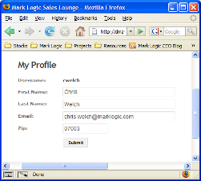

Flat Links
Element to use: <ul class=”flatlinks”>
Makes an unordered list display horizontally.

Drop Navigation
Element to use: <div class=”dropnav”>

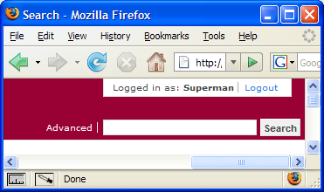

Messages
Element to use: <div class=”message”>
Used for form messages and similar.
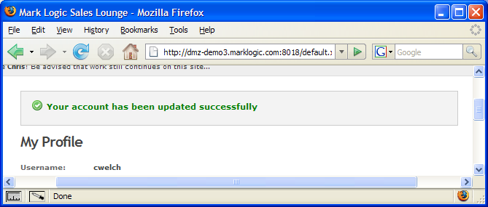

Pagination
Element to use: <div class=”pages”>
